

Product Documentation

Table of Contents

**1. Product Overview** 1

**2. User Flows & Journey** 2

**3. System Architecture (Technical)** 7

**4. Features & Specifications** 9

**5. Business Rules & Policies** 13

**6. Roadmap & Milestones** 15

**7. Operational Documentation** 16

**8. Property Purchase Flow** 17

**9. Security & Compliance** 20

**10. Investor / Legal Appendices** 21

Table of Figures

Figure 1: Desktop and Mobile Views of Home Screen 1

Figure 2: Desktop and Mobile Views of Account Creation - Client 2

Figure 3: Desktop and Mobile Views of Property Search - Client 3

Figure 4: Desktop and Mobile Views of Listing Details Page 3

Figure 5: Desktop and Mobile Views of Account Creation – Agent 4

Figure 6: Desktop and Mobile Views of Dashboard - Agent 4

Figure 7: Desktop and Mobile Views of Dashboard - Agency Admin 5

Figure 8: Desktop and Mobile Views of Agency Members - Agency Admin 5

Figure 9: Desktop and Mobile Views of Analytics - Agency Admin 5

Figure 10: Desktop and Mobile Views of Users - Platform Admin 6

Figure 11: Desktop and Mobile Views of Legal Documents Page - Platform Admin 6

Figure 12: System Architecture Diagram - Hava 7

Figure 13: Desktop and Mobile Views of User Profile Management 10

Figure 14: Desktop and Mobile Views of Add Listing Page 10

Figure 15: Desktop and Mobile Views of Edit Listing Page 11

Figure 16: Desktop and Mobile Views of Listings Management Page 11

Figure 17: Desktop and Mobile Views of Agency Creation 12

Figure 18: Desktop and Mobile Views of Chat - Client 12

Figure 19: Desktop and Mobile Views of Chat - Agent 13

Figure 20: Desktop and Mobile Views of Add Legal Document 13

Figure 21: Desktop and Mobile Views of Subscription Model 14

Figure 22: Roadmap Timeline - Hava 15

Figure 23: Property Purchase Flow 17

Figure 24: Security & Compliance Workflow 21

**1. Product Overview**

Hava is a comprehensive real estate platform designed to streamline property transactions in Nigeria. It serves as a centralized hub connecting property seekers (clients), real estate agents, and agencies, facilitating a more transparent and efficient property search and management process.

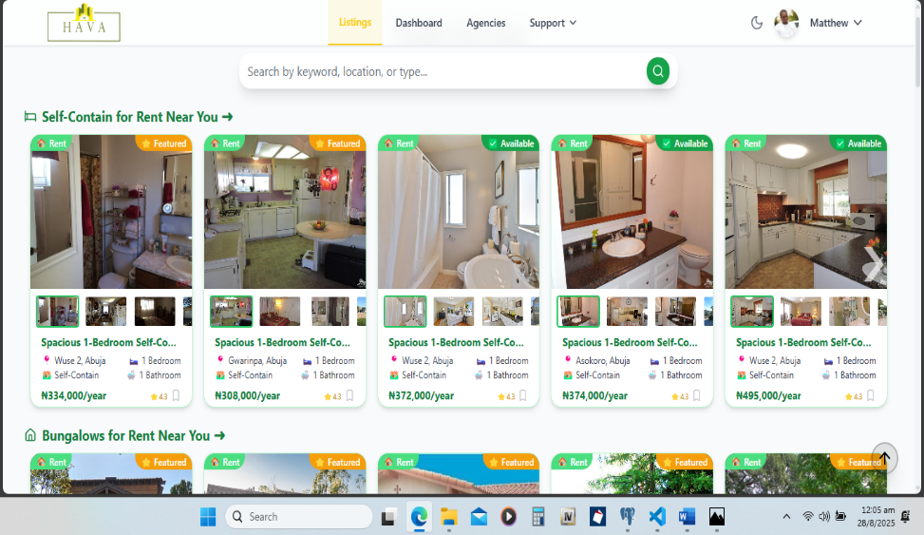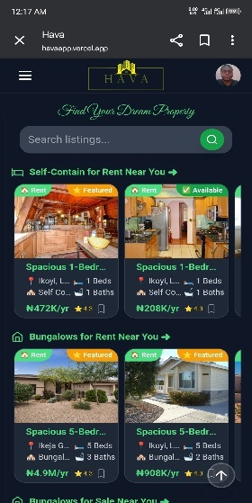

Figure 1: Desktop and Mobile Views of Home Screen

**1.1. Purpose and Value Proposition**

The core purpose of Hava is to modernize the Nigerian real estate market by addressing key pain points for all stakeholders:

* **For Clients:** Hava provides a user-friendly interface to search for a wide range of properties, connect with verified agents, and manage their property inquiries in one place. The platform aims to enhance the property search experience by offering detailed listings, advanced search filters, and direct communication channels with agents.
* **For Agents:** Hava empowers individual real estate agents with tools to manage their listings, track client inquiries, and build their professional profiles. By connecting with agencies, agents can expand their reach and collaborate with a larger team.
* **For Agencies:** The platform offers a suite of tools for real estate agencies to manage their team of agents, oversee property listings, and gain insights into their business performance through analytics.

**1.2. Target Audience**

Hava's target audience can be segmented into three main groups:

* **Property Seekers (Clients):** Individuals and families looking to buy, rent, or lease properties in Nigeria.
* **Real Estate Agents:** Licensed and independent real estate professionals seeking to manage their listings and connect with clients and agencies.
* **Real Estate Agencies:** Companies that employ multiple agents and require a platform to manage their collective listings and operations.

**1.3. Key Goals and Objectives**

* To become the leading online real estate marketplace in Nigeria.
* To provide a secure and trustworthy platform for all property transactions.
* To empower real estate professionals with the tools they need to succeed.
* To simplify the property search process for clients.

**2. User Flows & Journey**

This section outlines the primary user flows for the different roles within the Hava platform.

**2.1. Client User Journey**

The client's journey is focused on finding and inquiring about properties.

Figure 2: Desktop and Mobile Views of Account Creation - Client

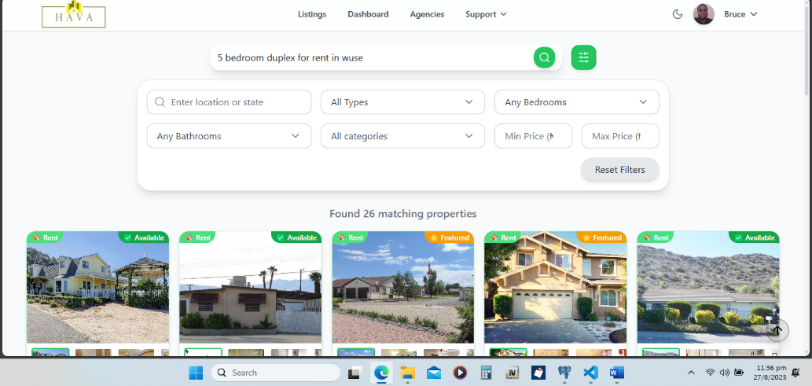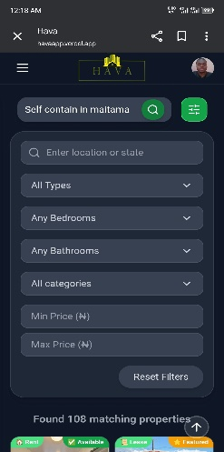

Figure 3: Desktop and Mobile Views of Property Search - Client

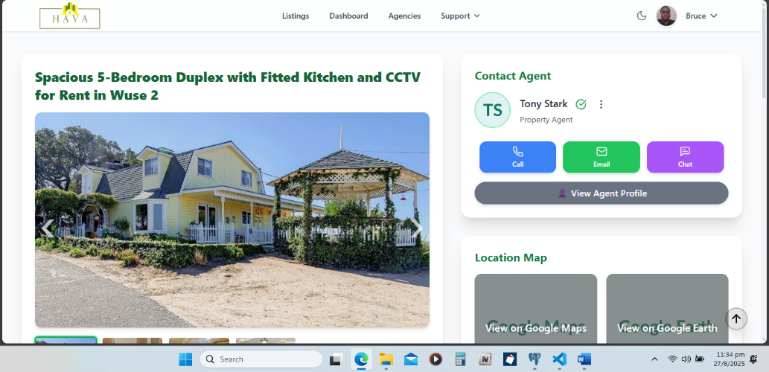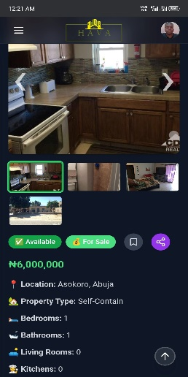

Figure 4: Desktop and Mobile Views of Listing Details Page

1. **Registration/Login:** A new user signs up as a "Client" or logs into their existing account.
2. **Property Search:** The client uses the search bar and filters (location, price, property type, etc.) to find suitable properties.
3. **View Listing Details:** The client clicks on a property to view detailed information, including images, amenities, and agent contact information.
4. **Save to Favorites:** The client can save listings they are interested in to their favorites for later viewing.
5. **Make an Inquiry:** The client sends a message to the agent associated with the listing to ask questions or schedule a viewing.
6. **Manage Inquiries:** The client can view and manage all their conversations with agents in their dashboard.

**2.2. Agent User Journey**

The agent's journey revolves around managing listings and interacting with clients.

Figure 5: Desktop and Mobile Views of Account Creation - Agent

Figure 6: Desktop and Mobile Views of Dashboard - Agent

1. **Registration/Login:** An agent signs up, selecting the "Agent" role, or logs in.
2. **Join an Agency (Optional):** An agent can request to join an existing agency to be part of a team.
3. **Create and Manage Listings:** The agent can add new property listings, including details, images, and pricing. They can also edit or delete existing listings.
4. **Manage Inquiries:** The agent receives and responds to inquiries from clients through their dashboard.
5. **Manage Clients:** The agent can view a list of clients who have made inquiries and manage their interactions.

**2.3. Agency Admin User Journey**

The Agency Admin's journey is focused on managing the agency's agents and overall performance.

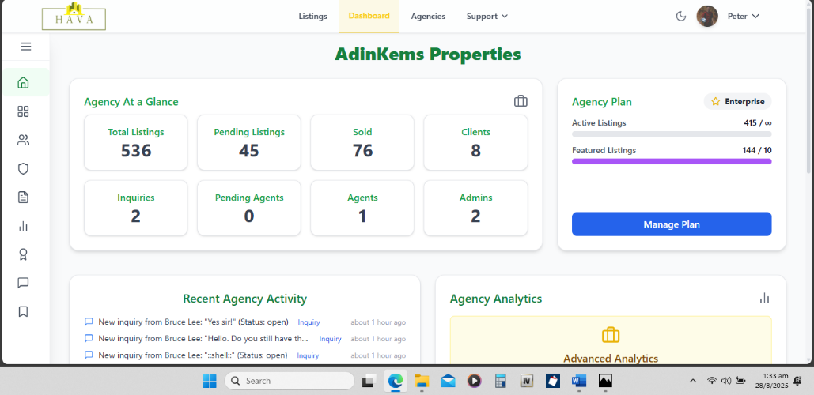

Figure 7: Desktop and Mobile Views of Dashboard - Agency Admin

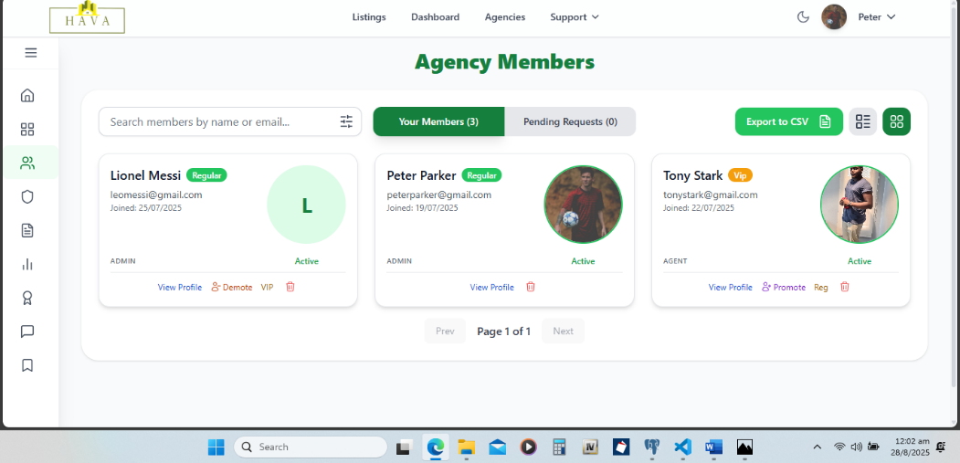

Figure 8: Desktop and Mobile Views of Agency Members - Agency Admin

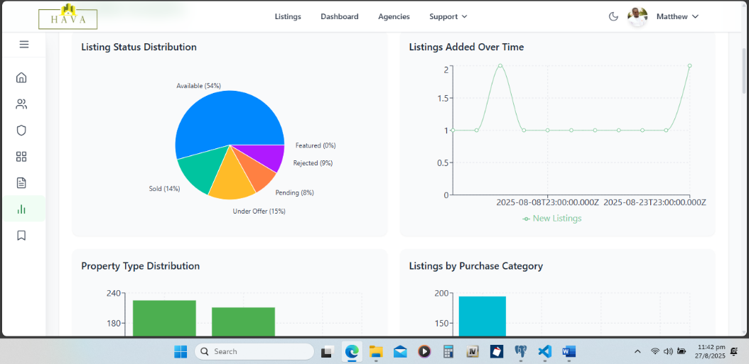

Figure 9: Desktop and Mobile Views of Analytics - Agency Admin

1. **Registration/Login:** An agency administrator signs up or logs in. They can either register a new agency or be promoted to an admin role within an existing one.
2. **Manage Agency Members:** The admin can approve or reject requests from agents wanting to join the agency. They can also remove agents from the agency.
3. **Oversee Listings:** The admin has a view of all listings created by the agents within their agency.
4. **Analytics:** The admin can view performance metrics for the agency, including the number of listings, inquiries, and agent performance.

**2.4. Platform Admin User Journey**

The Platform Admin's journey is focused on managing the entire Hava platform, including all users, agencies, listings, and platform-wide analytics.

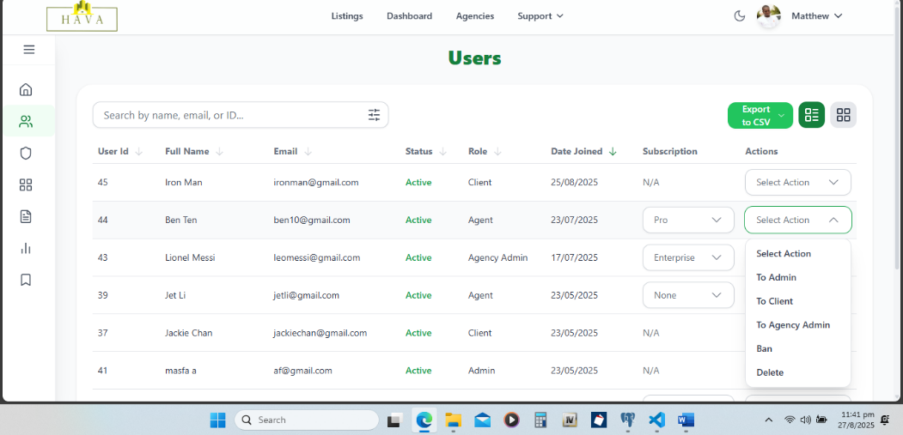

Figure 10: Desktop and Mobile Views of Users - Platform Admin

Figure 11: Desktop and Mobile Views of Legal Documents Page - Platform Admin

1. **Registration/Login:** The Platform Admin signs in with credentials provided at onboarding, gaining access to the full admin panel.
2. **Manage Users:** The admin can view, search, and filter all clients, agents, and agency admins. They can approve, suspend, or remove users, and monitor user activity.
3. **Manage Agencies:** The admin can view all registered agencies, approve or reject agency registrations, and oversee agency compliance and performance.
4. **Oversee Listings:** The admin has a view of all property listings across the platform and can edit, approve, or remove listings as needed.
5. **Analytics & Reports:** The admin can access platform-wide metrics such as total users, total listings, inquiries, revenue/commissions, and active vs inactive agencies/agents.
6. **Legal & Compliance:** The admin can manage Terms of Service, Privacy Policy, and platform-wide notices, as well as oversee flagged content and dispute resolution.

**3. System Architecture (Technical)**

Hava is built on a modern web stack, separating the frontend and backend for a scalable and maintainable application.

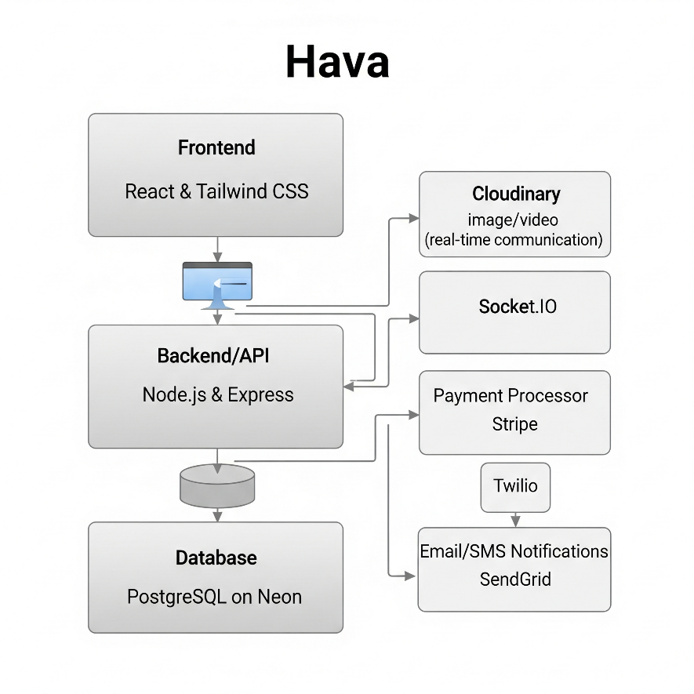

Figure 12: System Architecture Diagram - Hava

**3.1. Frontend**

* **Framework:** React.js (hava-frontend)
* **Styling:** Tailwind CSS for a utility-first styling approach. Hava supports both light and dark modes, demonstrated across desktop and mobile screenshots.
* **State Management:** React Context API for managing global state like authentication and theme.
* **Routing:** React Router for handling client-side navigation.
* **Key Libraries:**
  + **Axios:** For making HTTP requests to the backend API.
  + **Socket.IO Client:** For real-time communication (e.g., inquiries).
  + **Framer Motion:** For animations and transitions.

**3.2. Backend**

* **Framework:** Node.js with Express.js (hava-backend)
* **Database:** PostgreSQL (schema.sql)
* **Authentication:** JWT (JSON Web Tokens) for securing API endpoints.
* **Real-time Communication:** Socket.IO for instant messaging between clients and agents.
* **Image and Document Storage:** Cloudinary for storing and serving all user-uploaded images and legal documents.
* **Key Libraries:**
  + **pg:** PostgreSQL client for Node.js.
  + **bcryptjs:** For hashing user passwords.
  + **jsonwebtoken:** For creating and verifying JWTs.
  + **cors:** To enable Cross-Origin Resource Sharing.

**3.3. Database**

The database schema (schema.sql) is designed to support the core functionalities of the platform. Key tables include:

* users: Stores information about all users (clients, agents, admins).
* agencies: Contains details about real estate agencies.
* property_listings: The central table for all property listings.
* property_details: Stores additional details for each property.
* inquiries: Manages the communication threads between clients and agents.
* legal_documents: Stores metadata for uploaded legal documents.

**3.4. Deployment & Infrastructure**

* The frontend is configured for production builds via react-scripts build.
* The backend is set up to run on a Node.js server.
* The application is designed to be deployed on a platform like Render, as indicated by the .env.production file.

**4. Features & Specifications**

This section provides a detailed breakdown of the key features of the Hava platform.

**4.1. User Management**

|  |  |
| --- | --- |
| Feature | Specification |
| User Roles | The platform supports three main user roles: client, agent, and admin. There is also a sub-role of agency_admin. |
| Authentication | Users can sign up and sign in with an email/username and password. Passwords are securely hashed. |
| Profile Management | Users can update their profile information, including name, bio, and profile picture. |
| Role Selection | New users are prompted to select their role upon registration. |

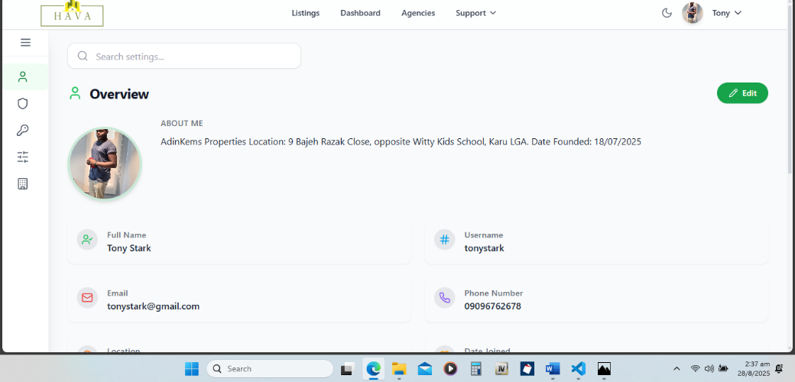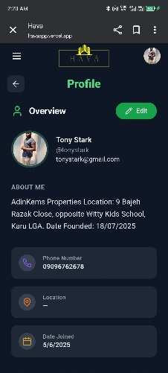

Figure 13: Desktop and Mobile Views of User Profile Management

**4.2. Listings Management**

|  |  |
| --- | --- |
| Feature | Specification |
| Create Listing | Agents and admins can create new property listings with a title, location, price, description, and images. |
| Edit Listing | The creator of a listing (or an admin) can edit its details. |
| Delete Listing | Listings can be deleted by their creator or an admin. |
| Search and Filter | Users can search for listings by keyword and filter by price, property type, location, and number of bedrooms/bathrooms. |
| Featured Listings | Admins can mark listings as "featured," which are highlighted on the platform. |

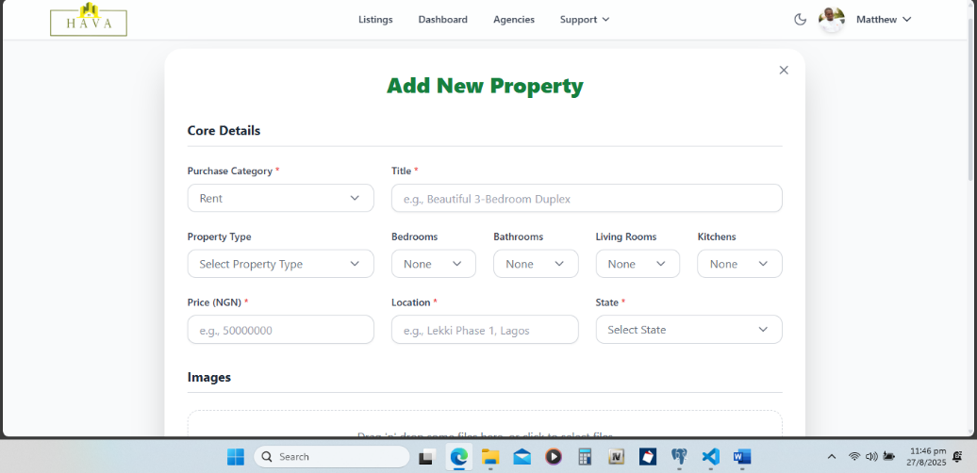

Figure 14: Desktop and Mobile Views of Add Listing Page

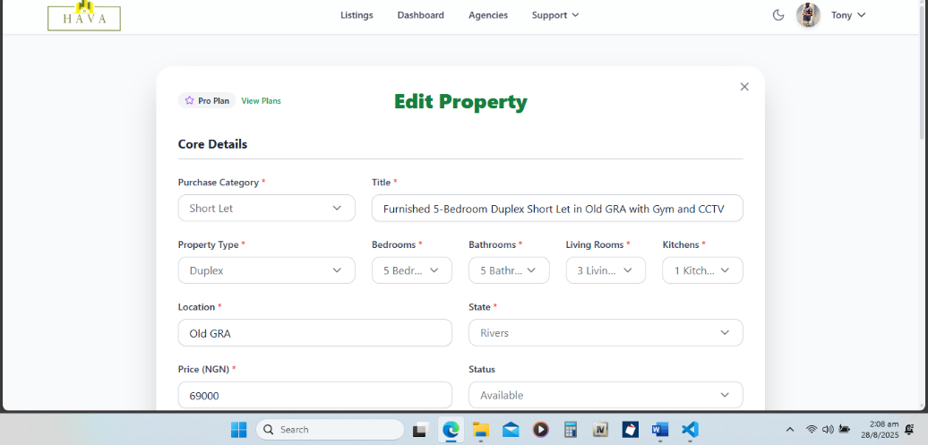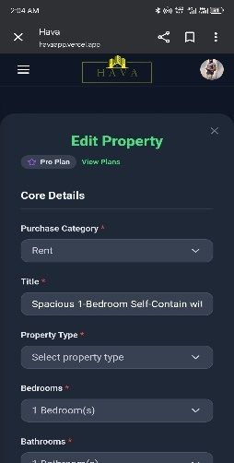

Figure 15: Desktop and Mobile Views of Edit Listing Page

Figure 16: Desktop and Mobile Views of Listings Management Page

**4.3. Agency Management**

|  |  |
| --- | --- |
| Feature | Specification |
| Create Agency | Admins can create new agencies. Agents can also register a new agency, becoming its first agency_admin. |
| Manage Members | Agency admins can approve or reject requests from agents to join their agency. |
| View Agency Listings | All listings from agents within an agency are visible to the agency admin. |

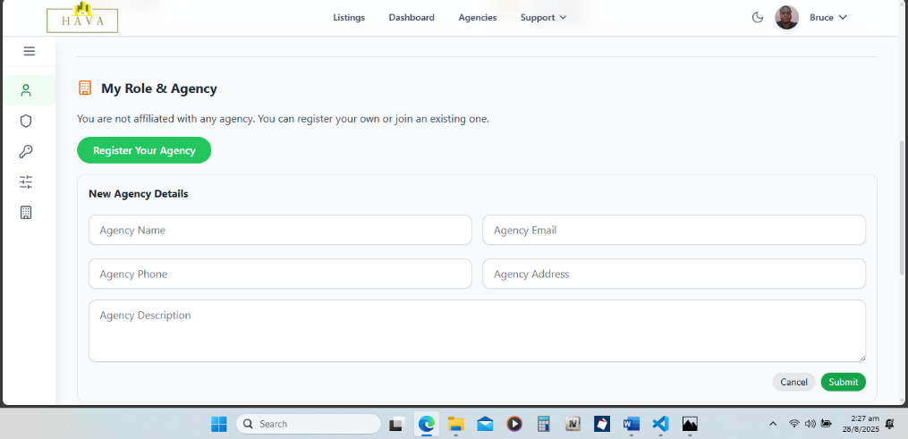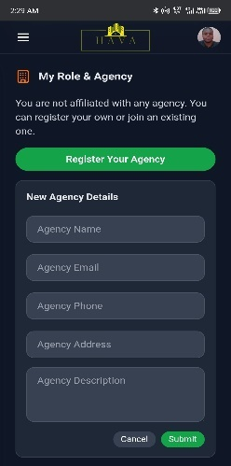

Figure 17: Desktop and Mobile Views of Agency Creation

**4.4. Inquiries and Communication**

|  |  |
| --- | --- |
| Feature | Specification |
| Client Inquiries | Clients can send inquiries about specific properties to the listing agent. |
| Real-time Chat | Inquiries are handled through a real-time chat interface powered by Socket.IO. |
| Inquiry Management | Both clients and agents have a dashboard to view and manage their ongoing conversations. |

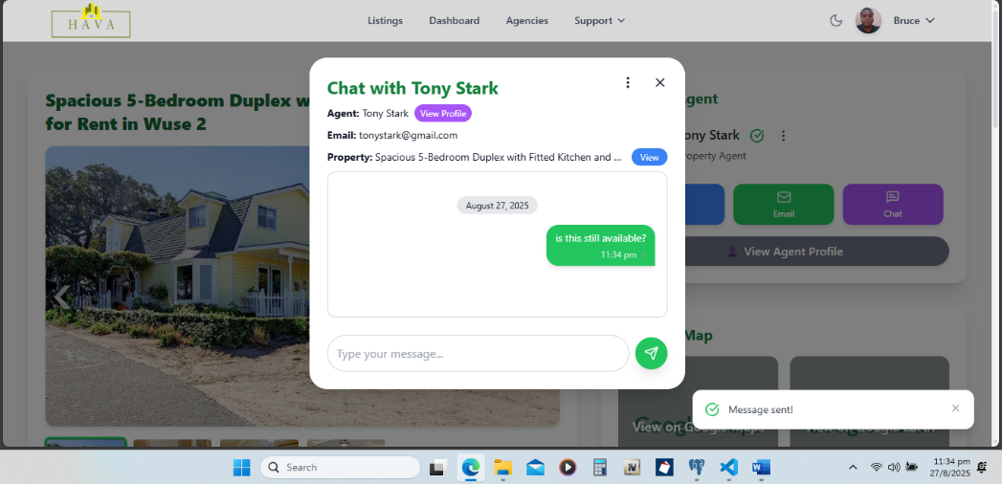

Figure 18: Desktop and Mobile Views of Chat - Client

Figure 19: Desktop and Mobile Views of Chat - Agent

**4.5. Document Management**

|  |  |
| --- | --- |
| Feature | Specification |
| Upload Legal Documents | Admins and agency admins can upload legal documents related to properties. |
| View Documents | Authorized users can view the uploaded documents. |
| Secure Storage | Documents are securely stored on Cloudinary. |

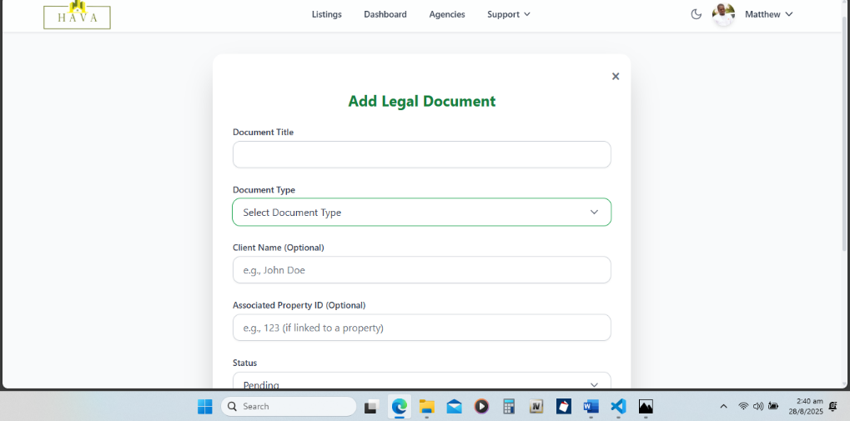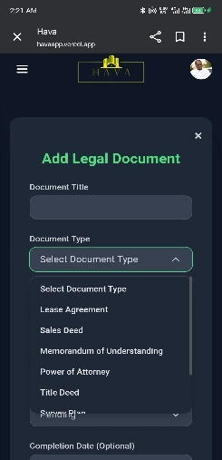

Figure 20: Desktop and Mobile Views of Add Legal Document

**5. Business Rules & Policies**

**5.1. Subscription Tiers**

Hava operates on a tiered subscription model for agents and agencies, defined in subscriptionConfig.js.

|  |  |  |  |
| --- | --- | --- | --- |
| Tier | Max Listings | Max Featured | Max Images |
| Basic | 5 | 0 | 5 |
| Pro | 20 | 5 | 15 |
| Enterprise | Unlimited | 10 | Unlimited |

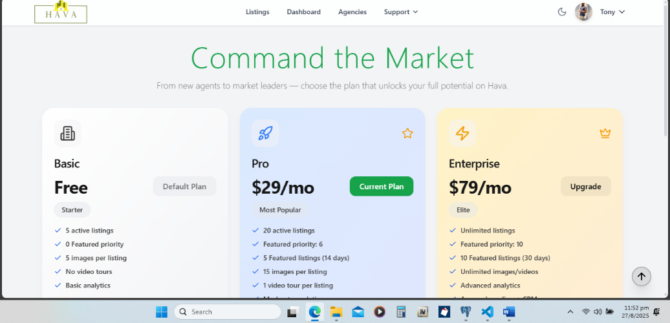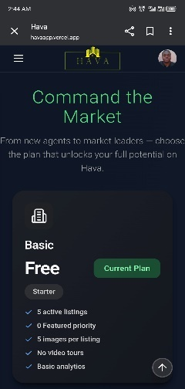

Figure 21: Desktop and Mobile Views of Subscription Model

**5.2. Authorization and Permissions**

* **Admin:** Has full access to all platform features, including user management, agency creation, and system settings.
* **Agency Admin:** Can manage their agency's members, listings, and view agency-specific analytics.
* **Agent:** Can create and manage their own listings and interact with clients.
* **Client:** Can search for properties, save favourites, and make inquiries.

**5.3. Listing Policies**

* New listings created by agents have a default status of "pending" and require admin approval.
* Featured listings have an expiration date and will be automatically un-featured after a set period.

**6. Roadmap & Milestones**

Hava’s roadmap balances product maturity, monetization, and market expansion. Each milestone is designed to achieve measurable growth targets while keeping the platform scalable and secure:

Figure 22: Roadmap Timeline - Hava

**6.1. Short-Term (Next 3-6 months)**

**Goal:** Launch and stabilize the MVP while building user trust.

* **Enhanced Analytics**: Introduce basic dashboards for agencies and agents, showing inquiries, listings, and engagement.
* **Mobile Applications**: Launch native iOS and Android apps to reach Nigeria’s mobile-first market.
* **Payment Integration**: Integrate a payment gateway (e.g., Paystack, Stripe) for subscription tiers and commissions.

**KPI:** Reach 10,000 monthly active users (MAU) and 500 active agencies.

**6.2. Mid-Term (6-12 months)**

**Goal:** Deepen product features and drive monetization.

* **Virtual Tours**: Enable 360° virtual property tours to enhance the client experience.
* **Mortgage Calculator**: Provide buyers with tools to estimate financing needs.
* **Advanced CRM Tools**: Offer agents features like client notes, reminders, and pipeline management.

**KPI:** Convert at least 30% of active agents to paid subscription tiers; reach 50,000 registered users.

**6.3. Long-Term (1-2 years)**

**Goal: Expand regionally and adopt intelligent features.**

* **Expansion Across Africa**: Launch Hava in at least two additional African markets (e.g., Ghana, Kenya).
* **AI-Powered Recommendations**: Use machine learning to match clients with properties based on preferences and behaviour.
* **Legal Services Integration**: Partner with legal firms to offer in-platform property transaction services (contracts, verification).

**KPI:** Surpass 100,000 registered users and achieve profitable unit economics.

**7. Operational Documentation**

**7.1. Database Management**

* **Backup:** The pgAdmin4_Backup_Guide.pdf provides instructions for manually backing up the PostgreSQL database. Automated backup will should be implemented for production.
* **Schema:** The complete database schema is defined in schema.sql. Any changes to the database structure will be managed through migrations.
* **Sequence Resets:** SQL scripts are provided (id_sequence fix.sql, id_sequence fix listings.sql) to reset primary key sequences, if necessary, typically after a data import or restoration.

**7.2. Maintenance**

* **Scheduled Jobs:** A cron job (expireFeatured.js) runs daily to expire featured listings.

**7.3. Deployment**

* The frontend application is built for production using npm run build.
* The backend is a standard Node.js application that can be deployed to any platform supporting Node.js.
* Environment variables for the database URL, Cloudinary credentials, JWT secret, and other sensitive information must be configured on the deployment server.

**8. Property Purchase Flow**

Hava’s client purchase flow takes users from property discovery to post-purchase, covering search, exploration, inquiry, verification, and payment, all reinforced by backend processes, real-time chat, and compliance for transparency.

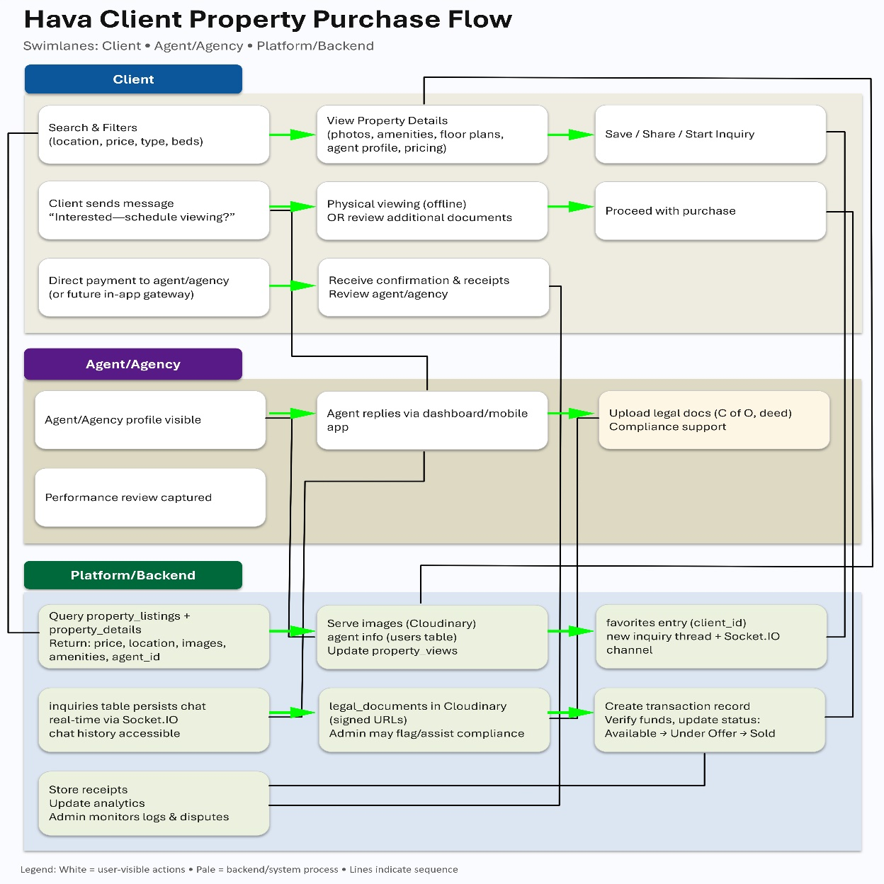

Figure 23: Property Purchase Flow

**8.1. Property Discovery**

**User Action:**

* Client searches using filters (location, price, property type, bedrooms, etc.).
* From results, they click on a property they like.

**System Process:**

* Frontend sends request → Backend → Database (property_listings, property_details).
* Returns property metadata (price, location, images, amenities, agent ID).
* Images are pulled from Cloudinary, agent info from users table.

**8.2. Property Exploration**

**User Action:**

* Client views **property details page** with:
  + Photos (swipeable gallery)
  + Description, amenities, floor plans
  + Agent/Agency profile
  + Pricing & availability
  + Legal document previews (if available)
* Client can:
  + Save to **Favorites**
  + Share listing
  + Start an **Inquiry (chat)** with the agent

**System Process:**

* property_views counter is updated (analytics).
* If favorited → entry stored in favorites table linked to client ID.
* If inquiry starts → new thread in inquiries table; real-time Socket.IO channel opened between client ↔ agent.

**8.3. Inquiry & Communication**

**User Action:**

* Client sends a message: *“I’m interested in this property, can I schedule a viewing?”*
* Agent replies via chat (available in dashboard and mobile app).
* Client and agent may agree on a physical inspection or a virtual tour (future roadmap).

**System Process:**

* Inquiry stored in inquiries table (linked to property + agent + client).
* Socket.IO ensures **real-time delivery**.
* Both parties can access chat history in their dashboards.

**8.4. Viewing & Verification**

**User Action:**

* Client visits property (offline step), or reviews additional documents uploaded by the agent/agency.
* Agent may upload legal docs (e.g., C of O, deed) into legal_documents table.
* Client verifies property authenticity (possibly assisted by Platform Admin checks).

**System Process:**

* Documents stored in Cloudinary with signed URLs (secure access).
* Platform Admin may flag suspicious listings or assist in compliance checks.

**8.5. Purchase Initiation**

**User Action:**

* If satisfied, client chooses to proceed with purchase.
* Options:
  1. Direct payment to agent/agency (current flow if no payment gateway yet).
  2. In future: Pay securely via in-app payment gateway (Stripe/Paystack).

**System Process:**

* Transaction record created in transactions table.
* Payment service verifies funds and updates backend.
* Listing status updated (e.g., from **Available → Under Offer → Sold**).

**8.6. Post-Purchase**

**User Action:**

* Client receives confirmation, transaction receipts, and access to related legal documents.
* Can review agent/agency performance.

**System Process:**

* Receipt stored in backend.
* Analytics updated for agency/agent performance.
* Platform Admin monitors transaction logs for compliance and dispute resolution.

**9. Security & Compliance**

Trust is central to Hava’s mission. The platform is designed with **data protection, regulatory compliance, and platform integrity** at its core.

**9.1. Data Protection & Privacy**

* **NDPR Compliance:** Hava complies with the Nigeria Data Protection Regulation (NDPR), ensuring user data is processed lawfully, securely, and with consent.
* **GDPR-Readiness:** The platform is designed with global best practices in mind, making it adaptable to GDPR and other international standards as Hava expands into new markets.
* **User Privacy:** Client contact information is only disclosed to agents upon inquiry approval, protecting user data from unnecessary exposure.

**9.2. Security Measures**

* **Authentication & Access Control:** JWT-based authentication and bcrypt-hashed passwords. Role-based access ensures clients, agents, agency admins, and platform admins only access authorized features.
* **Encryption:** All sensitive data is encrypted at rest (PostgreSQL) and in transit (TLS/HTTPS).
* **Backups & Recovery:** Automated daily backups of critical data, with tested restoration procedures to ensure continuity in case of outages.
* **Audit Logs:** Platform Admin has visibility into key actions (user creation, listing modifications, deletions, and document uploads).

**9.3. Content Moderation & Compliance**

* **Listing Approval Workflow:** All new agent listings default to “pending” and require admin approval to maintain listing integrity.
* **Flagged Content:** Users can report suspicious or fraudulent listings; flagged content is escalated to Platform Admin for review.
* **Secure Document Management:** Legal documents uploaded by admins and agency admins are stored securely on Cloudinary with access restricted through signed URLs.

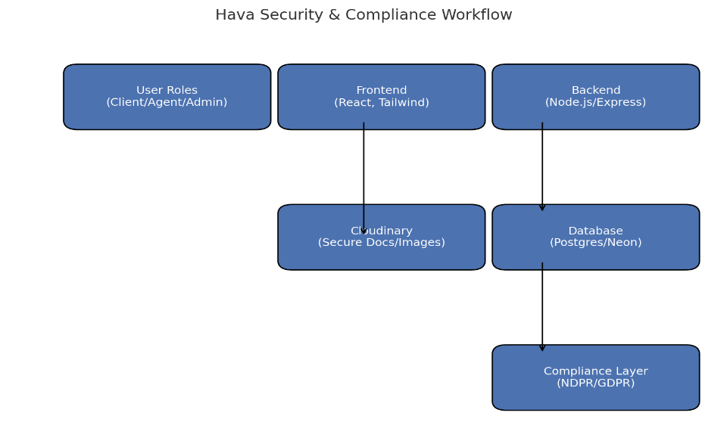

Figure 24: Security & Compliance Workflow

**10. Investor / Legal Appendices**

The *Investor and Legal Appendices* provide supporting documentation designed for external stakeholders such as investors, legal counsel, and strategic partners. These materials go beyond the technical scope of the product documentation to highlight Hava’s commercial viability, governance model, and compliance considerations. They serve as a bridge between the platform’s technical foundations and the operational, financial, and legal frameworks that will sustain its long-term growth.

The directory includes **Hava Business Proposal.docx**, which presents the problem, solution, target market, and monetization plan; **Hava Investor Documentation.docx**, which details growth projections, revenue models, risks, and exit strategies; and **Agency Admin Roles and Privileges.docx**, which defines responsibilities and authority within agency operations. Together, these appendices provide transparency, aid investor due diligence, and establish key terms for regulatory compliance.

**10.1. Document Highlights**

**10.1.1. Hava Business Proposal.docx**

* Executive summary: vision, mission, and the real estate problems Hava solves.
* Market analysis: target audience, competitor landscape, and opportunity sizing.
* Business model: revenue streams (listing fees, commissions, premium services).
* Launch roadmap: MVP → growth → expansion phases.

**10.1.2. Hava Investor Documentation.docx**

* Financial projections: user growth, revenue forecasts, and break-even timeline.
* Investment structure: equity allocation, fundraising needs, and investor returns.
* Risk analysis: operational, legal, and market risks with mitigation strategies.
* Exit opportunities: acquisition, IPO, or long-term profitability scenarios.

**10.1.3. Agency Admin Roles and Privileges.docx**

* Role definition: what authority an agency admin has on Hava.
* Membership management: approving, removing, and supervising agents.
* Listing oversight: responsibility for accuracy, compliance, and disputes.
* Accountability: legal and financial responsibilities of agencies on the platform.